**KARMAVEER KAKASAHEB WAGH INSTITUTE OF ENGINEERING EDUCATION AND RESEARCH**



**MINI PROJECT REPORT**

**ON**

**“Plant/Fruit growth determination using color sensor.”**

***Submitted by***

Nikhil D. Ahire (71925523G)

Harshali S. Kor (71810374C)

Mohammadmajid A. Pathan (71925548B)

**DEPARTMENT OF ELECTRONICS AND TLECOMMUNICATION ENGINEERING**

**YEAR 2019-2020**

**KARMAVEER KAKASAHEB WAGH INSTITUTE OF ENGINEERING EDUCATION AND RESEARCH**



**CERTIFICATE**

This is to certify that the project work entitled **“Plant/Fruit growth determination using color sensor”,** has been successfully completed during the academic year of 2018-2019 by the following students:

Nikhil D. Ahire (71925523G)

Harshali S. Kor (71810374C)

Mohammadmajid A. Pathan (71925548B)

This project conforms to the standards laid down by SPPU and has been completed in satisfactory manner as a partial fulfillment for the bachelor’s degree in Electronics Engineering, SPPU.

**Prof. D. D. Khartad Prof. Dr. D. M. Chandwadkar Prof. Dr. K.N. Nandurkar**

**Project Guide H.O.D. Principal**

**ACKNOWLEDGMENT**

The success and final outcome of this project required a lot of guidance and assistance from many people and we are extremely privileged to have got this all along the completion of our project. All that we have done is only due to such supervision and assistance and we would not forget to thank them.

We would like to express our respect and thanks to the people who have helped us most throughout our project.

We express our gratitude to **Prof.** **Dr. D. M. Chandwadkar** Head of Department of Electronics and Telecommunication for his constant encouragement, co-operation and support.

We are grateful to our project guide **Prof. Dipankar D. Khartad** for nonstop support for the project.

We express our sincere thanks to **Staff of E&TC Department** for their unfailing inspiration.

We are also thankful to **lab faculty** for providing the lab facilities. A special thank of us goes to ourselves (Group Members) for everyone’s precious contribution in completing the project, where everyone exchanged his own interesting ideas, thoughts and made this possible to complete our project with all accurate information. We wish to thank our parents for their personal as well as financial support and attention who inspired us to go our own way. At last but not the least we want to thank our friends who treasured us for our hard work and encouraged us.

Nikhil Ahire

Harshali Kor

Majid Pathan

**ABSTRACT**

An automated system for measuring plant/fruit color, as an indicator of crop growth status, has been developed for plantlets growing in a modified micro propagation system. Our system includes a RGB (red, green and blue) color sensor. Fruit color sensors provide information, in a non-destructive manner, on the health status of tissue by comparing the sensor outputs to pre-determined optimum values.[3] These low cost color sensors can be incorporated into a continuous automated system for monitoring the color of growing plants. Subtle color changes can be an early indication of stress from less than optimum nutrient concentrations. [1] When combined with automated image color sensing for growth analysis, growth rate is detected using a color schemes. In this project we developed a system detect plant growth using RGB sensor and compare it with a standard color schemes.

**CONTENTS**

1. Introduction ……………………………………………………………... 6
2. Literature Survey………………………………………………………… 7
3. System Details ………………………………….……………………...... 8

3.1 Project Specification

3.2 Block Diagram

3.3 Description of blocks

1. Design………………………………………………………………….. 10

4.1 Working of Circuit Diagram

4.2 Design of Circuit Diagram

4.3 Algorithm & Flowchart

4.4 PCB design

5. Testing ………………………………………………………………… 16

1. Results……………………………………………………….................. 17

Advantages and Applications................................................................... 17

Conclusion…..…………………………………………………………. 17

Future Scope..……………………………………………….................. 17

1. Webpage developed for project

References.……………………………………..………………………. 18

**Appendix**

1. Bill of Material
2. Datasheets

1. **INTRODUCTION**

Quality is not a single well-defined attribute but comprises many properties or characteristics. Appearance is one of the major factors the consumer uses to evaluate the quality of food products. In nowadays, not every farmer can determine the total duration required for growth of crops. So many farmers suffer from huge loss due to lack of quality of their crops. And so many times there is one reason behind the poor quality of crop. i.e. Imperfect Growth. [1] Some crops lose their quality due to incomplete growth/ripening. Some lose their quality due to over ripening. The appearance of a product as judged by its color can often be used to determine the pigment content of a product, which in turn is often an index of quality. Color is one of the most important quality components of fresh fruit and vegetables. Fruit ripening is a complex genetically programmed process that culminates in dramatic changes in texture, color, flavor and aroma. [1]

So to implement this, **we have designed a system that recognizes the growth status of crop using its color.** This system requires sensor systems for plant recognition and differentiation. The system described in this work is based on programmable true-color sensors for real-time recognition and identification of color of crop plants. Our system is inexpensive and ready for practical use in farm land.

1. **LITERATURE SURVEY**

In this section describes various approaches for detecting the disease in plant leaf using image processing technique

**Sachin D. Khirade & et al… [1]** Identification of the plant growth is the key to preventing the losses in the yield and quantity of the agricultural product. It requires tremendous amount of work, expertize in the horticulture, and also require the excessive processing time. Hence, image processing is used for the detection of plant growth. Growth detection involves the steps like image acquisition, image pre-processing, image segmentation, feature extraction and classification. This paper discussed the methods used for the detection of plant growth using their leaves/fruits images. This paper discussed various techniques to segment the growth of the plant. This paper also discussed some Feature extraction and classification techniques to extract the features of infected leaf and the classification of plant diseases. The accurately detection of the plant growth is very important for the successful cultivation of crop and this can be done using image processing. This paper discussed various techniques to segment the growth of the plant. The use of ANN methods for classification of disease in plants such as self- organizing feature map, back propagation algorithm, SVMs etc. can be efficiently used. From these methods, we can accurately identify and classify various plant diseases using image processing technique.

**Mr. Pramod S. landge, Sushil A. Patil& et al… [2]** In this propose and experimentally evaluate a software solution for automatic detection of plant growth through Image Processing. Farmers in rural India have minimal access to agricultural experts, who can inspect crop images and render advice. Delayed expert responses to queries often reach farmers too late. This paper addresses this problem with the objective of developing image processing algorithms that can recognize problems occurred while growing crops from images, based on color, texture and shape to automatically detect growth that might affect crops and give the fast and accurate solutions to the farmer. The design and implementation of these technologies will greatly aid in selective chemical application, reducing costs and thus leading to improved productivity, as well as improved produce.

1. **SYSTEM DETAILS**
   1. **Project Specification**
      1. **Atmega 328P**

* Operating Voltage 1.8 V to 5.5 V
* CPU-RISC 8 Bit AVR
* No. of Pins 28
* Program Memory 32KB
  + 1. **TCS 3200 Color Sensor**
* Supply Voltage 6 V
* Input Voltage Range -0.3 V to +0.3 V
* Operating Temperature Range −40°C to 85°C
  1. **Block Diagram**

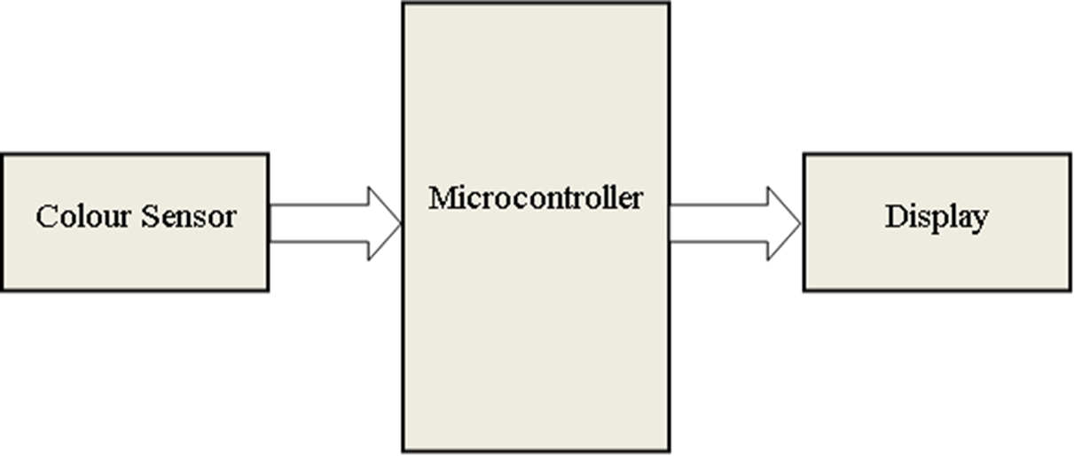

Figure 3.1: Block Diagram

* 1. **Description of Blocks**

There are different blocks used for different functions, here each block is explained step by step.

* + 1. **Color Sensor**

The TCS3200 Color sensor makes use of a TAOS TCS3200 RGB light-to-frequency chip. The TCS3200 color sensor operates by illuminating the object with two white LEDs, while an array of photo detectors (each with a red, green, blue and clear filter) interpret the color being reflected by means of a square wave output whose frequency is proportional to the light reflected. The TSC3200 Color sensor has a 5.6-mm lens, which is positioned to allow an area of 3.5 mm2 to be viewed. It is used to detect the color scheme of crop. [3]

* + 1. **Microcontroller**

Microcontroller receives RGB values from Color Sensor. Likewise, three RGB values will be stored in controller and it will be compared with standard values and based on this comparison the estimated growth time will be displayed on the 16x2 LCD. [3]

* + 1. **Display**

16x2 LCD Display is used to show the output of the system. Plant growth and estimated time required to complete growth of plant will be displayed on this display. [3]

1. **DESIGN**

**4.1 Working of Circuit Diagram**

There are different components used in circuitry, which have different function. Here we have explained working of circuit step by step.

**4.1.1 Working of Color Sensor**

The TCS3200 senses color light with the help of an 8 x 8 array of photodiodes. Then using a Current-to-Frequency Converter the readings from the photodiodes are converted into a square wave with a frequency directly proportional to the light intensity. If we take a closer look at the sensor we can see how it detects various colors. The photodiodes have three different color filters. Sixteen of them have red filters, another 16 have green filters, another 16 have blue filters and the other 16 photodiodes are clear with no filters. Each 16 photodiodes are connected in parallel, so using the two control pins S2 and S3 we can select which of them will be read. So for example, if we want to detect red color, we can just use the 16 red filtered photodiodes by setting the two pins to low logic level according to the table. [3]

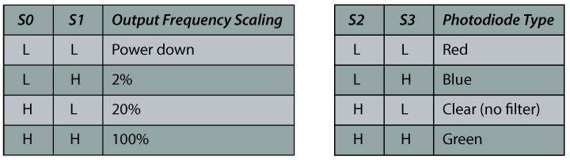

Figure 4.1: Pin Selections

The sensor has two more control pins, S0 and S1 which are used for scaling the output frequency. The frequency can be scaled to three different preset values of 100 %, 20 % or 2%. This frequency-scaling function allows the output of the sensor to be optimized for various frequency counters or microcontrollers. [3]

**4.1.2 Interfacing of Color Sensor with Atmega328P**

Initially we tested the working of system on the Arduino board. First we defined the pins to which the sensor is connected and defined a variable for reading the frequency. In the setup section we needed to define the four control pins as outputs and the sensor output as an Arduino input. Here we also needed to set the frequency-scaling, for this example we will set it to 20%, and start the serial communication for displaying the results in the Serial Monitor. In the loop section, we started with reading the red filtered photodiodes. For that purpose, we set the two control pins S2 and S3 to low logic level. Then using the “pulseIn()” function we read the output frequency and put it into the variable “frequency”. Using the Serial.print() function we printed the result on the serial monitor. The same procedure we did for the two other colors; we just needed to adjust the control pins for the appropriate color. [3]

After that we ran the Serial Monitor and we started getting some values. These values depend on the selected frequency-scaling, as well as from the surrounding lighting. here that three values differ due to the different sensitivity of each photodiode type, as seen from the photodiode spectral responsivity diagram from the datasheet of the sensor. [3]

Hence, to represent the detected colors with the RGB Model which has values from 0 to 255, we used the map() function to map or convert the readings to the values from 0 to 255.[3]

The value of 70 will be mapped to 0, and the value of 25 to 255. The same procedure goes for the two other colors. [3]

**4.1.3 Displaying the output on LCD:**

* We have been using the built in LiquidCrystal library provided by Arduino along with their IDE for LCDs that are based on Hitachi HD44780 (or compatible) chipset.

We have used following functions to show the output content on display. [2]

1. **LiquidCrystal object_name(rs,rw,en,d0,d1,d2,d3,d4,d5,d6,d7)**

* This function defines an object named object_name of the class LiquidCrystal.
* rs, rw and en are the pin numbers of the Arduino board that are connected to rs, rw and en of LCD.
* d0, d1, d2, d3, d4, d5, d6 and d7 are the pin numbers of the Arduino board that are connected to data pins D1, D2, D3, D4, D5, D6 and D7 of LCD.
* LiquidCrystal lcd(13, 12, 11, 10, 9, 8, 7, 6, 5, 4, 3). This makes use of LCD in 8-bit mode.
* LiquidCrystal lcd(13, 12, 11, 6, 5, 4, 3). This makes use of LCD in 4-bit mode

1. **lcd.begin(cols,rows)**

* This function is used to define the number of rows and columns the LCD has and to initialize the LCD.
* Needs to be called before calling other functions, once the object is defined using the function in point 1.
* For 16x2 LCD we write lcd.begin(16,2). lcd is the name of the object of the class LiquidCrystal. 16 is the number of columns and 2 is the number of rows.

**III. lcd.createChar(num,data)**

* This function is used to create a new custom character for use on the LCD.
* num is the CGRAM location (0 to 7) at which the custom character is to be stored.
* data is array of eight bytes which represent the custom character.
* Custom character can be of 5x8 pixels only.
* Each custom character is specified by an array of eight bytes, one for each row. The five least significant bits of each byte determine the pixels in that row.
* To display a custom character on the screen, write() function needs to be used. CGRAM location number (0 to 7) of the custom character which is to be displayed on LCD is passed as an argument to the write function.
  1. **Design of Circuit Diagram**

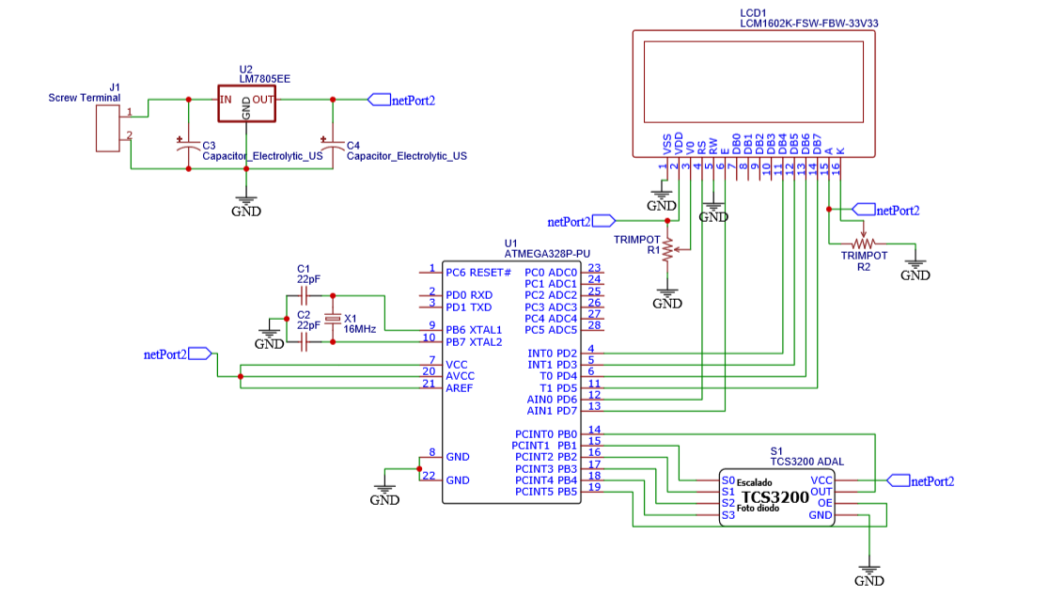

Figure 4.2: Circuit Diagram

**Why 22pf capacitors for crystal oscillator?**

* The general pin capacitance is given as 10pF in the Atmega328 datasheet. This is high compared to other modern µControllers. But it need not necessarily be the capacitance of the XTAL pins, aw the clock driver circuit differs from other I/O. [2]
* By using the CKOPT fuse, an internal capacitance of 36pF can be added, which is recommended for the 32kHz quartzes. [2]
* Cheap caps come in 20% accuracy, so there is little use taking other things but E3 values 10, 22, 47. [2]
* So 22 fits closest. [2]
  1. **Flowchart**

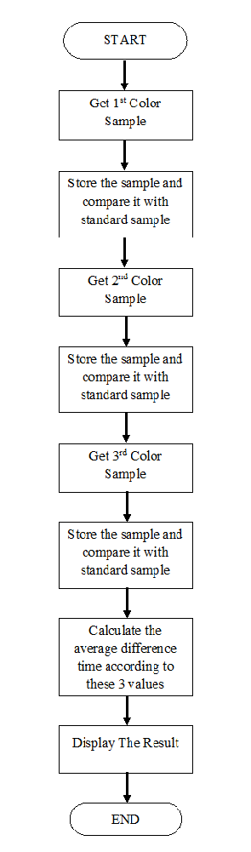

Figure 4.3: Flow Chart

* 1. **PCB Design**

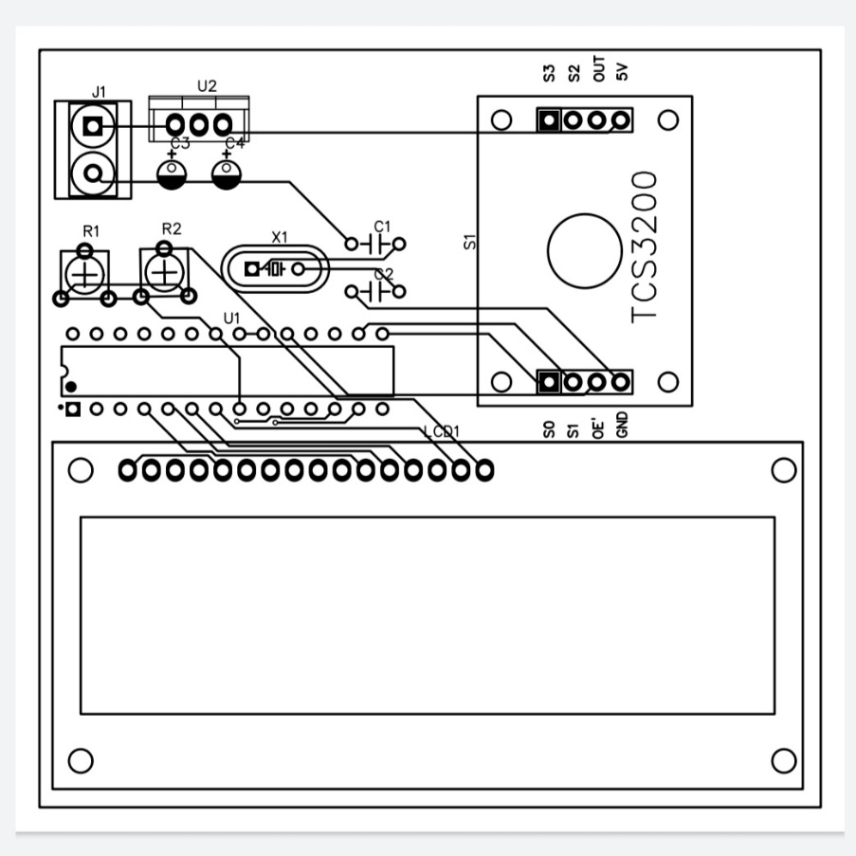

Figure 4.4.1: PCB Layout

1. **TESTING**

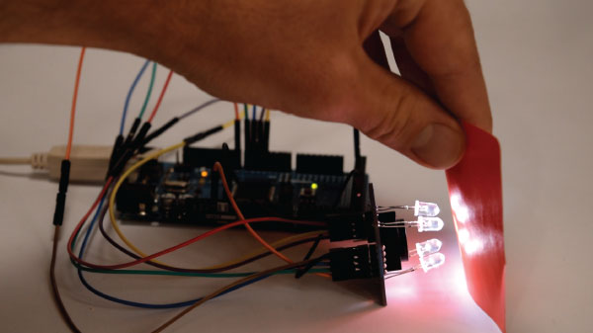

Figure 5.1: Testing Color Samples

After turning on the circuitry and detecting the color sample we ran the Serial Monitor and we started getting some values. These values depend on the selected frequency-scaling, as well as from the surrounding lighting. [3] Here that three values differ due to the different sensitivity of each photodiode type, as seen from the photodiode spectral responsivity diagram from the datasheet of the sensor.

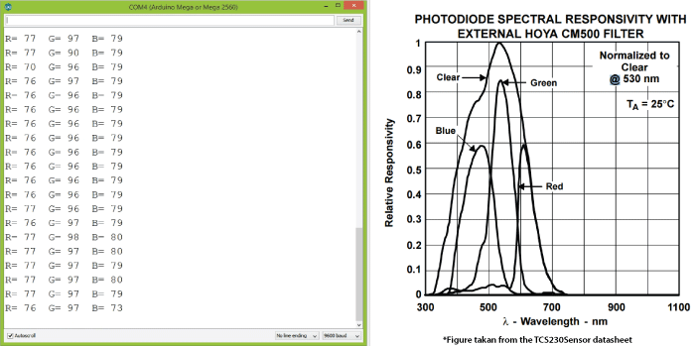

Figure 5.1: Serial Monitor window after getting output

1. **RESULTS**

**6.1 Advantages**

1. Easy to Design.
2. Compact in Size.
3. Low Cost.
4. Inexpensive maintenance due to inexpensive components.

**6.2 Applications**

1. In agriculture field to detect the daily growth of crops.
2. To get estimated growth period of crops.

**6.3 Conclusion and Future Scope**

Experimental results show that the Parallax TCS3200 is a

useful low cost colour sensor, which following calibration can

provide accurate RGB readings. It is therefore a useful

component for integrating into an automated monitoring

system such as a robotic arm, with various other sensors, for

the monitoring and control of plants growing in a modified

plant micropropagation system. Future work involves

completing the entire robotic system with fully integrated

sensors. This will allow investigations to be carried out to

optimise plant growth based on the information obtained from

the colour sensors, by relating colour information to plant

quality. This will be further enhanced by additional growth

data obtained from captured plant images. The use of NIR

sensors offers further potential for non-destructive assessments

of plant tissue structure.

Experimental results show that the Parallax TCS3200 is a

useful low cost colour sensor, which following calibration can

provide accurate RGB readings. It is therefore a useful

component for integrating into an automated monitoring

system such as a robotic arm, with various other sensors, for

the monitoring and control of plants growing in a modified

plant micropropagation system. Future work involves

completing the entire robotic system with fully integrated

sensors. This will allow investigations to be carried out to

optimise plant growth based on the information obtained from

the colour sensors, by relating colour information to plant

quality. This will be further enhanced by additional growth

data obtained from captured plant images. The use of NIR

sensors offers further potential for non-destructive assessments

of plant tissue structure.

With the calibration factor determined, the TCS3200 was able to identify the color of selected plant material. Experimental results show that the TCS3200 is a useful low cost color sensor, which following calibration can provide accurate RGB readings. It is therefore a useful component for integrating into an automated monitoring system, with various other sensors, for the monitoring of plants growth. Future work involves completing the entire system with fully integrated sensors. This will allow investigations to be carried out to give more accurate status of plant growth based on the information obtained from the color sensors, by relating color information to plant quality. This will be further enhanced by additional growth data obtained from captured plant images. The use of NIR sensors offers further potential for non-destructive assessments of plant tissue structure.

**Webpage of Project:**

<http://nixtech.epizy.com/mini_project.html?i=1>

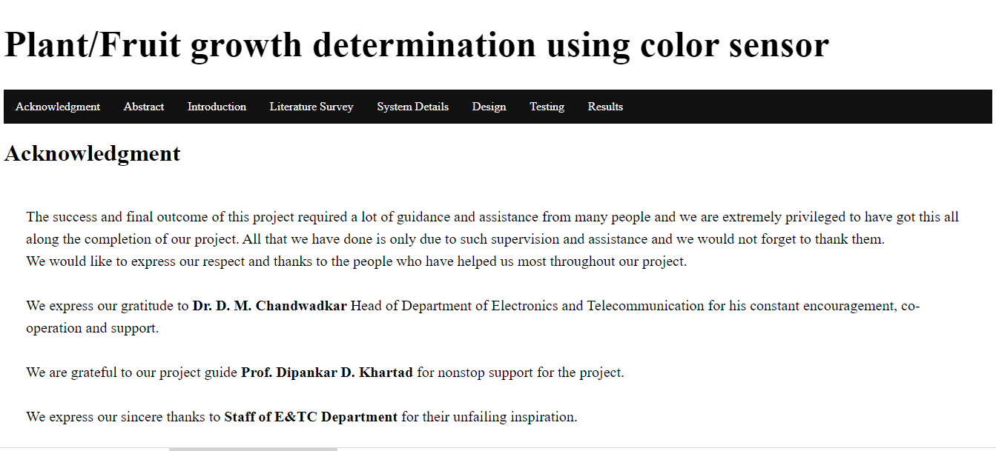

**REFERENCES**

1. Seelye, Mark & Sen Gupta, Gourab & Bailey, Donald & Seelye, John. (2011). Low cost color sensors for monitoring plant growth in a laboratory. IEEE Instrumentation and Measurement Technology Conference. 1 - 6. 10.1109/IMTC.2011.5944221
2. <https://www.arduino.cc/reference/en/#functions>
3. Ch.Shravani, G. Indira & V. Appalaraju. Arduino Based Color Sorting Machine using TCS3200 Color Sensor. International Journal of Innovative Technology and Exploring Engineering (IJITEE). 1-3. ISSN: 2278-3075, Volume-8, Issue- 6S4, April 2019

**APPENDIX 1**

**Bill of Material**

|  |  |  |
| --- | --- | --- |
| Sr. No. | Component | Cost |
| 1. | ATmega328P µController | ₹175/- |
| 2. | Color Sensor TCS3200 | ₹433/- |
| 3. | PCB | ₹35/- |
| 4. | Connecting Pins for Testing on breadboard | ₹20/- |
| TOTAL | | ₹663/- |

**APPENDIX 2**

1. **Datasheet of ATmega328P**
2. **Datasheet of TCS3200**

**\***please follow the next page.